**NAME – KARAN DAS**

**USER ID – 34763**

**MAIL-** [**karannnx20@gmail.com**](mailto:karannnx20@gmail.com)

**Date – 7th Aug 2025**

**Topic Assignment:**

1. Intunewin conversion - Compatible version to upload to Intune
2. Interactive and Non-Interactive Applications
3. Process Flow for an Application on Windows client via IME service. (From Polling to detection, to installation, to detection and toast notifications as success/failure)
4. Specific Registries with Application GUID which give you the status of Installation/Uninstallation.
5. Registries with respect to LOB and Win32Apps

**Practice activity:**

**1. Intunewin conversion - Compatible version to upload to Intune.**

INTUNEWIN file:-

An Intunewin file is a special file used by Microsoft Intune to install apps on Windows devices.You create it using a tool called the **IntuneWinAppUtil**.

Steps to create a .intunewin file :-

1. Collect all installations file needed for install your application.

2. Use Win32 Content Prep Tool :-

Download and run IntuneWinAppUtil.exe

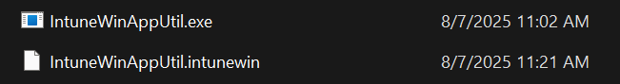

* + - Source folder
    - Setup file (setup.exe )
    - Output folder where .intunewin will be saved

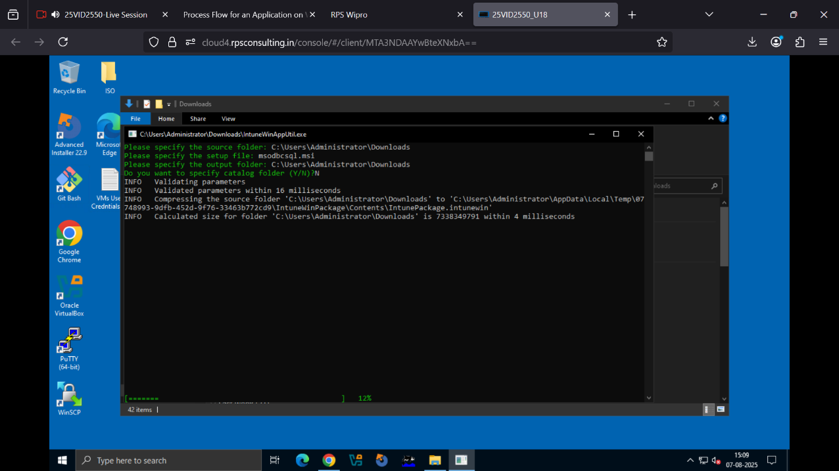

3 Create Intunewin file:-

The tool will automatically generate a intunewin file which all thing is consists on that file which we required for installation on intune .



4. Upload to Intune :-

* Go to Intune Admin Center
* Add a new Windows app (Win32)
* Upload the .intunewin file
* Enter install and uninstall commands

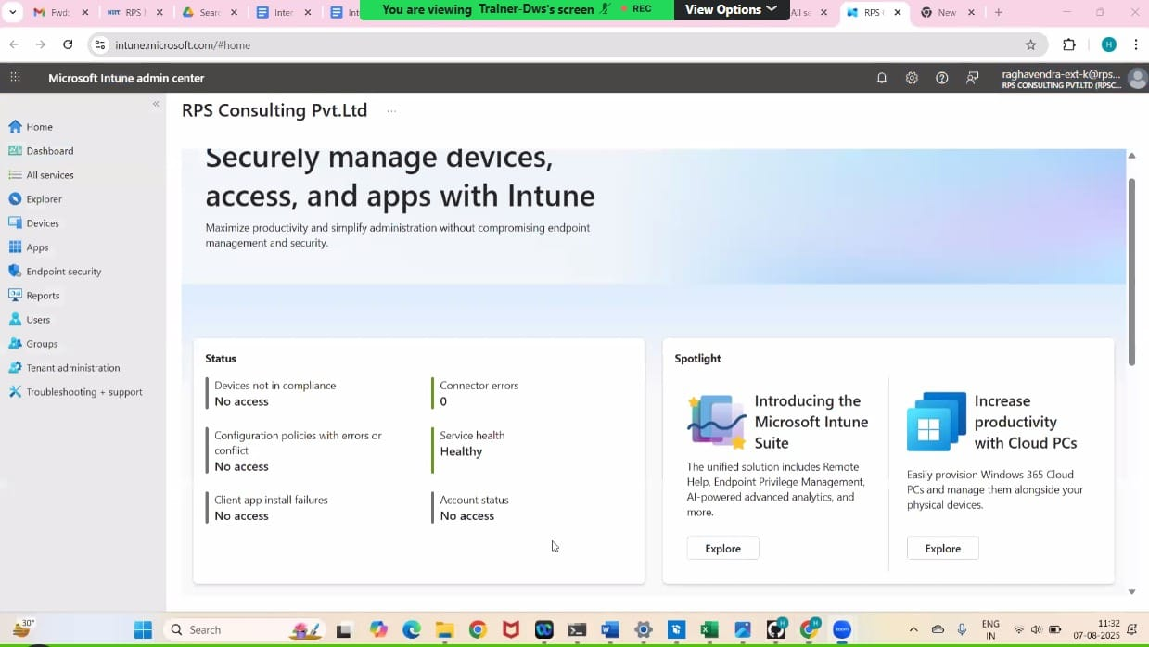

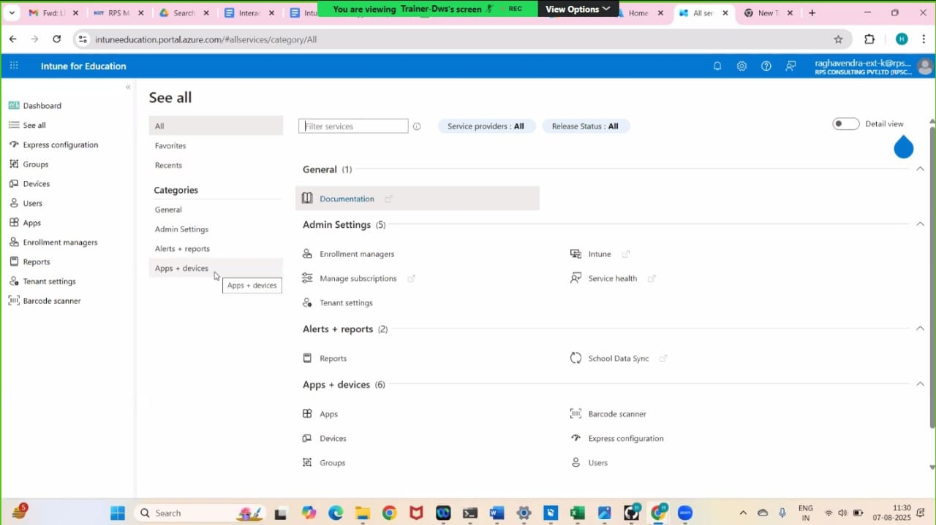

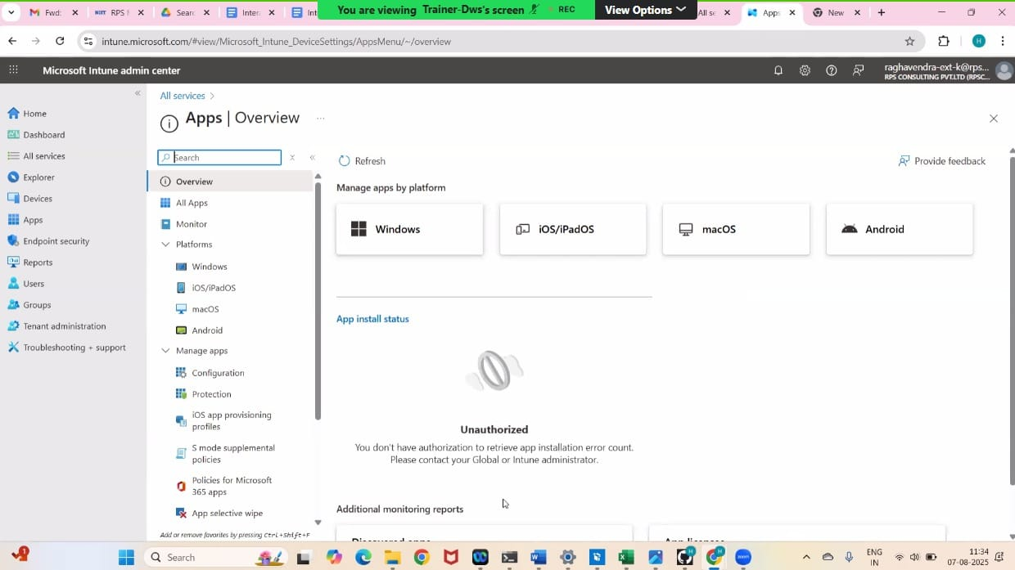

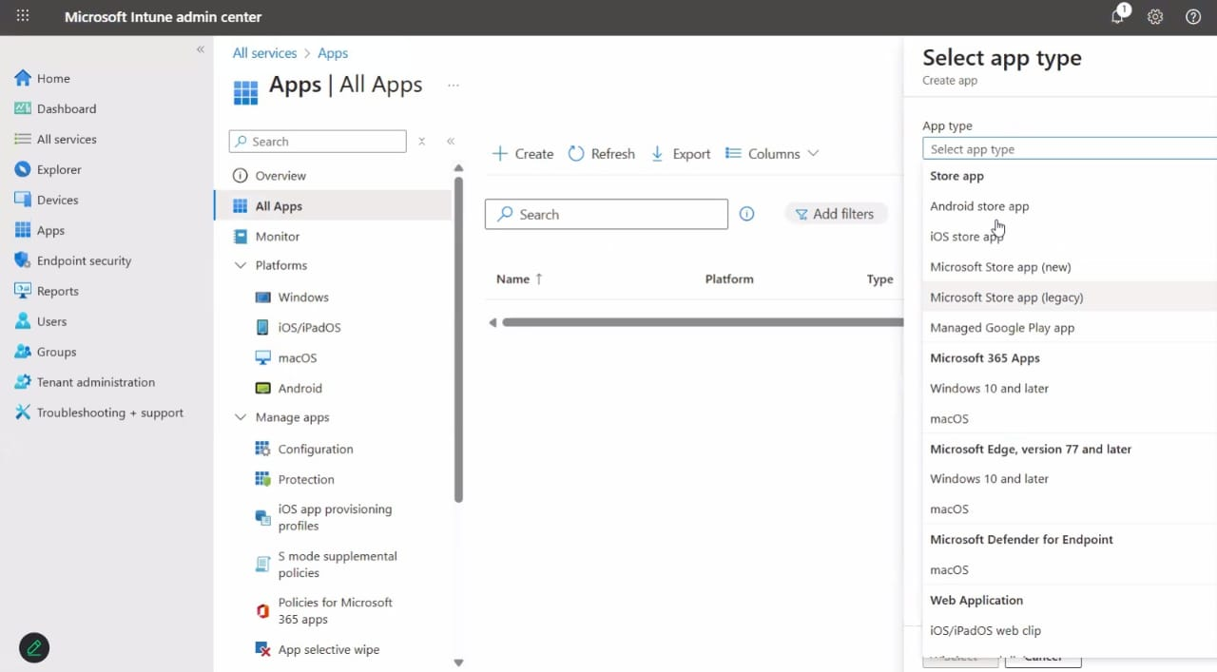

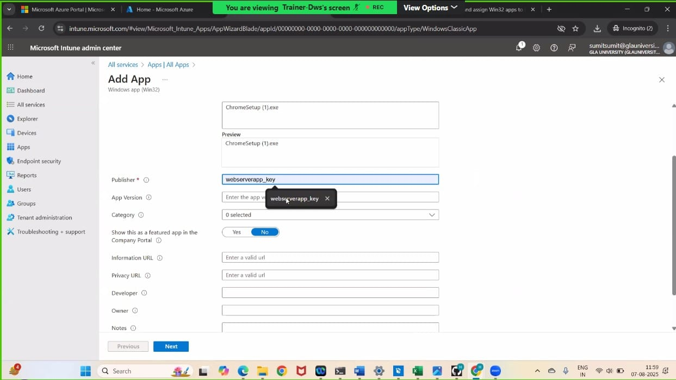

**2. Interactive and Non-Interactive Applications**

**Interactive applications** are programs that respond to user input in real time.

Examples :-

* Chat apps
* Games

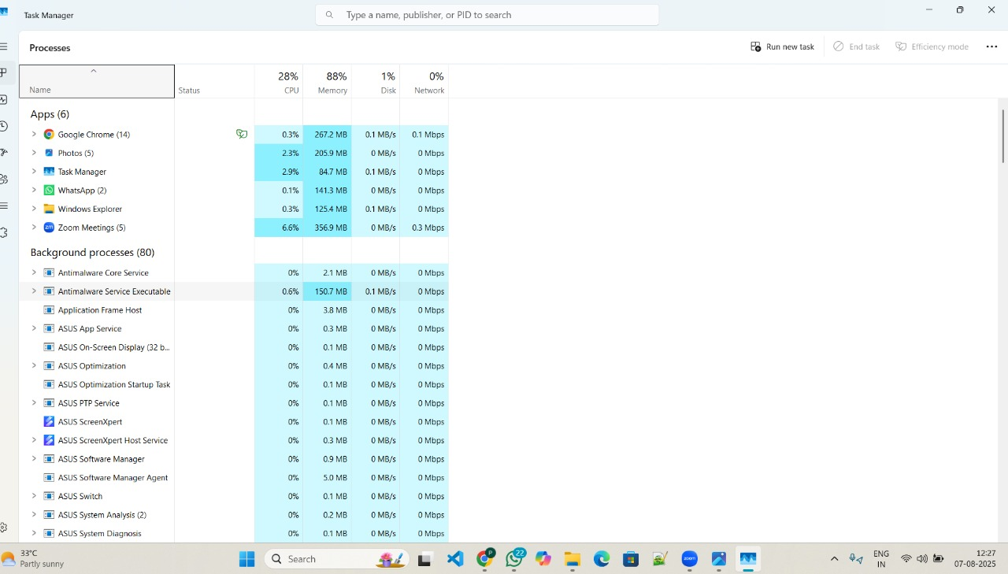

Non- Interactive apps

Interactive Apps

**Non-interactive applications** are programs that run without needing user input during execution.

Examples :

* Background updates
* Scheduled backups
* Antivirus scans

**3. Process Flow for an Application on Windows client via IME service. (From Polling to detection, to installation, to detection and toast notifications as success/failure).**

Process Flow for an Application on Windows client via IME service

1. Polling  
• IME checks Intune every 60 minutes for new apps or updates.

2. Detection  
• Before install: Checks if the app is already on the device.  
• After install: Checks if the app installed correctly.

3. Installation  
• If app is not found, it downloads and installs it silently.  
• If it fails or takes too long, it's marked as failed.

4. Detection & Notification  
• Checks again after install for success or failure.  
• Shows a popup saying app was installed or failed.  
• Device may restart if required.

**4. Specific Registries with Application GUID which give you the status of Installation/Uninstallation.**

**1.Registry Keys for Uninstall Information:**

* HKLM\SOFTWARE\Microsoft\Windows\CurrentVersion\Uninstall: This key stores information about programs installed for all users on the machine.

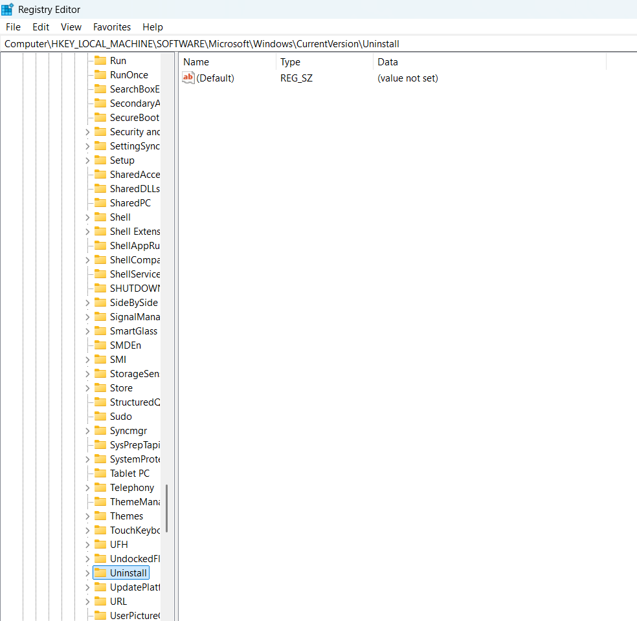

* HKCU\SOFTWARE\Microsoft\Windows\CurrentVersion\Uninstall: This key stores information about programs installed specifically for the current user.

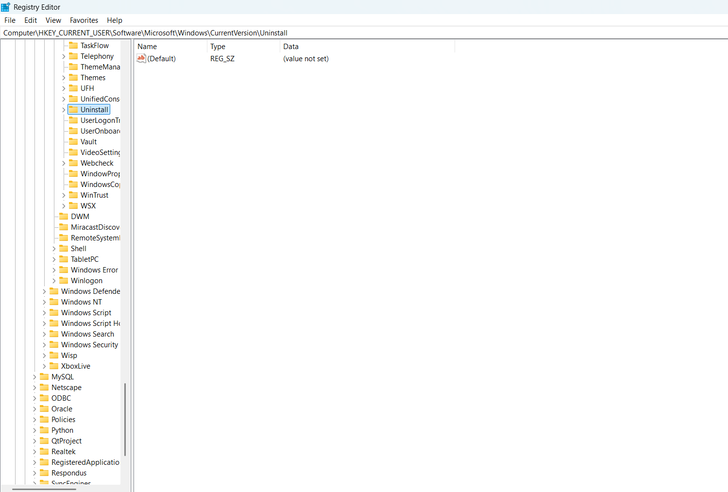

Windows stores uninstall details of installed apps in the Registry. We have find like we find in the above pictures .

Each app has a subkey like:

* DisplayName (app name)
* UninstallString (command to uninstall)
* Publisher
* InstallDate .

**5. Registries with respect to LOB and Win32Apps.**

LOB (Line-of-Business) Apps:-

* These are apps made by your company for internal use.
* Usually in .msi, .appx, or .msix format.
* Easy to upload and install using Intune.
* Used for simple apps with fewer settings.

Example: Your company’s attendance or payroll app.

Win32 Apps

* These are normal Windows apps like .exe or .msi.
* You must convert them to .intunewin format using a tool called IntuneWinAppUtil.
* Gives more control like:
  + Custom install commands
  + Uninstall options
  + Check if the app is already installed
  + Set app requirements
  + Control restart after install

Example: Chrome browser, Office, Zoom, or any setup with more options.